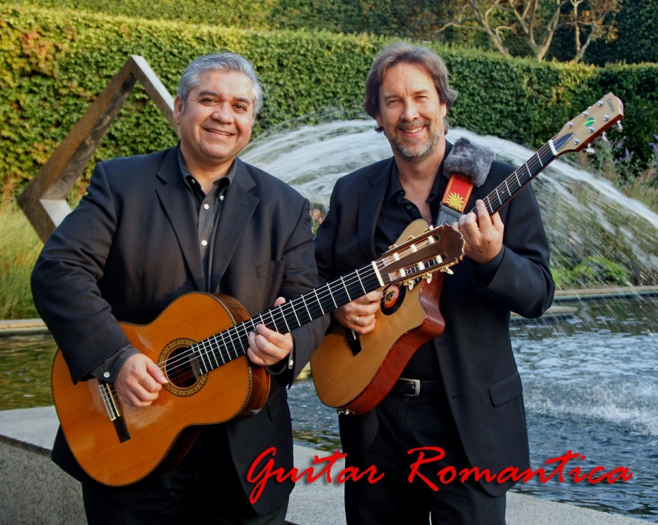

Acoustic guitar duo featuring jazzy Latin styles,

romantic ballads, and originals

Closely akin to Acoustic Alchemy, The Gipsy Kings, and Strunz and Farah, this music combines elements of Latin rhythms and Jazz, with beautiful chord voicings that combine nylon string acoustic guitar with steel string acoustic guitar for a unique and sometimes magical sound that can be relaxing as well as exciting.

Guitar Romantica has many years of experience playing all types of corporate events, parties, weddings, and five star restaurants and resorts. We have sold 1200 copies of our first CD entitled “Beyond Borders”, and 1000s of MP3s on iTunes, Rhapsody, MSN Music, etc.

Call or email Andrés or Kent for pricing and availability.

Andrés Carrasco: (714) 917-7119 [andres@guitarromantica.com](mailto:andres@guitarromantica.com)

Kent Lindsay: (310) 645-9568 [kent@guitarromantica.com](mailto:kent@guitarromantica.com)

Visit us on line at: [www.guitarromantica.com](http://www.guitarromantica.com)